**渤海大学本科毕业论文（设计）**

基于互联网的房地产系统的设计与实现

Design and Implementation of a Web-based Real Estate System

学院（系）： 信息科学与技术学院

专 业： 软件工程

学 号： WS1705006

学 生 姓 名： Mushonga Mafaro Shingai

入 学 年 度： 2017

指 导 教 师： 赵绪辉

完 成 日 期： 2020年11 月22日

# Chinese Abstract

中文摘要

本文的目的是解释设计和实现房地产网站。 它是专门为有兴趣查看财产并可能购买新房的人设计的。

本文的任务是通过分析，Web用户界面设计，数据库构建和连接，测试和实施为房地产公司建立房地产网站。 它对数据库使用HTML，PHP和SQL Server。 前端管理界面易于使用，方便用户浏览和获取信息。 用户还可以喜欢房子，并保存它们以供日后浏览，如果他们决定购买，则可以继续购买。 管理员可以使用不同于用户的自己的界面来访问后端，其中包括属性管理，用户管理等。关键字：HTML; CSS; JavaScript; MySQL; PHP; 房地产.

# English Abstract

The purpose of this article is to explain the design and implement a real estate web-based system. It is specially designed for people who are interested in viewing property and possibly buying a new house.

The goal is to establish a real estate website for real estate companies through analysis, Web user interface design, database construction and connection, testing and implementation. It uses HTML, PHP and SQL Server for the database. The front-end management interface is easy to use, convenient for users to browse and obtain information. The users can also like houses and save them to browse of view later, if they then decide to purchase, they can go ahead and do so. Administrators can use their own interface which is different from users to access the back-end functionalities, which includes property management, user management, agent management and so on.

Keywords: HTML; CSS; JavaScript; MySQL; PHP; Real Estate.

目 录

中文摘要 1

英文摘要 2

介绍 7

1 语言和框架 8

1.1语言能力: 8

1.1.1 HTML 8

1.1.2 CSS 8

1.1.3 PHP 9

1.1.4 JavaScript 9

1.1.5 MySQL 9

1.2 构架 9

1.2.1 甜蜜的警报 9

1.2.2 引导程序 10

2 需求分析 10

2.1 功能要求 10

2.2 信息浏览 10

2.3商业分析 10

2.4用户管理 11

2.5 住房 11

2.6 购买 11

2.7 安全 11

2.8 系统可靠性 11

3 系统设计 12

3.1 管理员 12

3.2 用户 13

4 前端 15

4.1 主页 15

4.2 注册页面 16

4.3 登录页面 17

4.4 用户页面 18

4.5 房屋和公寓页面 18

4.6 产品页面 18

4.7 管理员产品视图 19

5 后端 20

5.1 用户表 20

5.2 产品表 20

5.3 推车表 20

5.4 代理商表 21

6 网站软件测试 21

6.1 功能测试 21

6.1.1 可用性测试 21

6.1.2 接口测试 22

6.1.3 数据库测试 22

6.1.4 性能测试 22

6.2 安全测试 22

7 测试方法 22

8 结论 23

8 参考文献 24

TABLE OF CONTENTS

Chinese Abstract 1

English Abstract 2

Introduction 7

1 Languages and Frameworks 8

1.1 Languages: 8

1.1.1 HTML 8

1.1.2 CSS 8

1.1.3 PHP 9

1.1.4 JavaScript 9

1.1.5 MySQL 9

1.2 Frameworks 9

1.2.1 Sweet alert 9

1.2.2 Bootstrap 10

2 Requirements Analysis 10

2.1 Functional Requirements 10

2.2 Information Browsing 10

2.3 Business analysis 10

2.4 User Management 11

2.5 Housing 11

2.6 Purchasing 11

2.7 Security 11

2.8 System Reliability 11

3 System Design 12

3.1 Admin 12

3.2 User 13

4 Frontend 15

4.1 Homepage 15

4.2 Sign-Up Page 16

4.3 Log-In Page 17

4.4 User Page 18

4.5 House & Apartment Pages 18

4.6 Product Page 18

4.7 Admin Product View 19

5 The Backend 20

5.1 Users Table 20

5.2 Products Table 20

5.3 Cart Table 20

5.4 Agents Table 21

6 Website Software Testing 21

6.1 Functionality testing 21

6.1.1 Usability testing 21

6.1.2 Interface testing 22

6.1.3 Database testing 22

6.1.4 Performance testing 22

6.2 Security Testing 22

7 Methods of Testing 22

8 Conclusion 23

8 References 24

# Introduction

Real estate is the property, land, buildings, air rights above the land and underground rights below the land. The term real estate means real, or physical, property. “Real” comes from the Latin root *res*, or things. Others say it’s from the Latin word *rex*, meaning “royal,” since kings used to own all land in their kingdoms.

People turn to the internet when looking for new homes in today’s real estate world. A few years ago, you looked them up online on a desktop, got a map, and drove out to see a potential residence. Today, you grab a smartphone and go, because anything after that, you can look up on your phone. With the gigantic shift to a mobile internet, real estate agents need to stay in the game by increasing their web presence.

E-Commerce is short for Electronic Commerce. It refers to the activity of buying and selling products or services over the internet. With the help of the internet, people can buy and sell virtually everything, like books, electronics, apparel, software, furniture. E-commerce provides a platform for people to buy or sell whatever they want, whenever they want.

E-Commerce is an umbrella term that includes all business or commercial transactions. It defines the exchange of goods and services across the internet, without time and distance as barriers. Online auctions, payment gateways, internet banking, and online ticketing also come under e-commerce.

Essentially, an ecommerce website is one that allows a business to function almost entirely online, supplanting the need for a home office equipped with a sales and managerial staff. The process is automatic, and this is what makes it stand apart from other sites that still have business development as the main goal.

The purpose of the project is to provide housing to customers and allow them to browse properties from a remote location e.g. their own homes. Our goal is to make house hunting less stress full. The target audience is mainly for young adults all the way up to older people.

Real Estate has large potential for growth especially considering the amount of people we have worldwide, also considering that housing is a basic human right.

# 1 Languages and Frameworks

## 1.1 Languages:

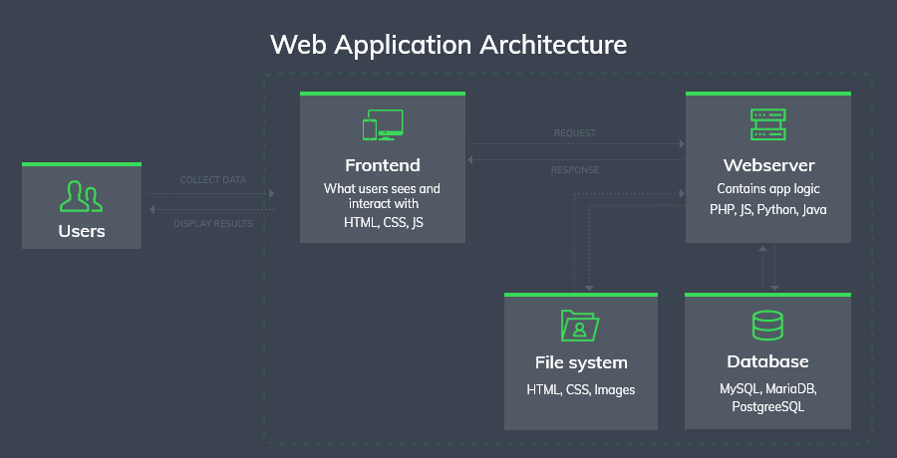

Figure 1.1

## 1.1.1 HTML

Hypertext Markup Language (HTML) is the standard markup language for documents designed to be displayed in a web browser. It can be assisted by technologies such as Cascading Style Sheets (CSS) and scripting languages such as JavaScript. HTML elements are the building blocks of HTML pages. With HTML constructs, images and other objects such as interactive forms may be embedded into the rendered page. HTML provides a means to create structured documents by denoting structural semantics for text such as headings, paragraphs, lists, links, quotes and other items.

## 1.1.2 CSS

Cascading Style Sheets (CSS) is a style sheet language used for describing the presentation of a document written in a markup language such as HTML. CSS is designed to enable the separation of presentation and content, including layout, colors, and fonts.

## 1.1.3 PHP

PHP is a general-purpose scripting language especially suited to web development. PHP code is usually processed on a web server by a PHP interpreter implemented as a module, a daemon or as a Common Gateway Interface (CGI) executable. On a web server, the result of the interpreted and executed PHP code – which may be any type of data, such as generated HTML or binary image data – would form the whole or part of a HTTP response. Various web template systems, web content management systems, and web frameworks exist which can be employed to orchestrate or facilitate the generation of that response. Additionally, PHP can be used for many programming tasks outside of the web context, such as standalone graphical applications and robotic drone control. Arbitrary PHP code can also be interpreted and executed via command-line interface (CLI).

## 1.1.4 JavaScript

JavaScript, often abbreviated as JS, is a programming language that conforms to the ECMAScript specification. JavaScript is high-level, often just-in-time compiled, and multi-paradigm. It has curly-bracket syntax, dynamic typing, prototype-based object-orientation, and first-class functions.

Alongside HTML and CSS, JavaScript is one of the core technologies of the World Wide Web. JavaScript enables interactive web pages and is an essential part of web applications. The vast majority of websites use it for client-side page behavior, and all major web browsers have a dedicated JavaScript engine to execute it.

## 1.1.5 MySQL

**MySQL** is a freely available open source Relational Database Management System (RDBMS) that uses Structured Query Language (**SQL**).

**SQL** is the most popular language for adding, accessing and managing content in a database. It is most noted for its quick processing, proven reliability, ease and flexibility of use. **MySQL** is an essential part of almost every open source **PHP** application. Good examples for PHP & MySQL-based scripts are WordPress, Joomla! and Drupal.

# 1.2 Frameworks

## 1.2.1 Sweet alert

Sweet Alert is a replacement for JavaScript's window.alert() function that shows very pretty modal windows. It's a standalone library that has no dependencies, and it's made from a JavaScript file plus a CSS file.

## 1.2.2 Bootstrap

Bootstrap is a free and open-source CSS framework directed at responsive, mobile-first front-end web development. It contains CSS- and (optionally) JavaScript-based design templates for typography, forms, buttons, navigation, and other interface components.

# 2 Requirements Analysis

Requirement analysis is to analyze and summarize the obtained user description information, that is, to extract and analyze user requirement information, and find the errors, omissions and deficiencies, so as to obtain the user's real requirements for the system and convert the user's needs into c a specification of requirements of computer software that can be achieved.

Requirements include functional and non-functional requirements. Functional requirements refer to the functions that the system needs to implement to develop the work to be performed. Non-functional requirements are system performance requirements, reliability requirements, operating environment constraints, etc.

## 2.1 Functional Requirements

The object of functional requirements analysis is the functional requirements of the website for the users who are going to use the website. From the user's use-habits and user experience to analyze the requirements of the site.

## 2.2 Information Browsing

The business requirements of real estate information browsing mainly including the information such as location, real-time information, etc. The website home page has an important job to provide the overall feeling for the users, so that the customers can have an intuitive impression of the whole system without having a hard time browsing and find valuable information to them. At the same time, it also needs to carry out fine design innovation, bring good application experience to the customers, and attract the customers' attention to housing information.

## 2.3 Business analysis

The real estate enterprise business requirements of the whole website can be divided into user management, housing product management and daily projects management.

## 2.4 User Management

This business includes user information management on the background which include the user login and user registration. The main functions include personal information registered when users use the website including personal information such as name and email. Registration information: including user name and password. The main functions of background user management include the administrator's classification management of user information in the background. So as to achieve the function of adding, deleting, modifying and querying user information.

## 2.5 Housing

When users find the houses they are interested in, they can click to view all the information, including the price, location and the agent’s contact. The user is also able to have a small preview of the house and the house’s description.

## 2.6 Purchasing

The purchasing done on this project is handled by the Stripe API. The User will insert their details and will allow the payment to process. Many hacking attacks happen due to the leakage of card/bank details and to avoid this, stripe creates a token from the submitted user details.

## 2.7 Security

Customers can access the service system only through registering and confirming in the system, and the customer cannot access any service information from the without registration, another factor is once users enter their details into the database, their passwords are hashed to avoid their information being exposed if somehow the system has been breached.

## 2.8 System Reliability

The Reliability of the System: Customers need a legitimate login system to accurately access all functionalities of the website.

# 3 System Design

## 3.1 Admin

The administrator is the master user of this website and the agent of management of the website backend. The administrator has all the information about all the users and about all products and services. The admin also has full control to make any changes such as editing data on a house.

1. View user information

The administrator can view the detail information of tourists who already exist in the website except passwords. User passwords are encrypted to avoid user’s accounts of being at risk.

1. Delete User

The administrator can delete a bad customer who may publish harmful information or illegal operation. So as to achieve the purpose of user information management.

1. Add Property

The admin can add products into the system through the page on their interface.

Once the house/apartment has been successfully added to the database it is now in the system and can be viewed by the users and also be purchased.

1. View Property

All products can be viewed by the admin in a simple table, the admin can view all details of the properties and also has the power to edit or even delete any of the products at their choosing.

1. Edit Property

If the details of the housing has been input incorrectly or if information has been changed for example if there is a new agent then the admin has the power to modify the details of the house in the edit page in their panel. Once the details have been edited the data will be updated in the database immediately.

1. Delete Property

If property have been bought the admin has to delete it because it has no more use being in the system. Another instance is if the house generally has no use being in the system any longer like if it has been burned down or if it is no longer for sale or lease any more.

1. Add Agents

All agents that work with the business are only added by the admin all their details such as commission and their names are added by the admin then saved into the database.

1. Delete Agents

If there is a case of an agents no longer working with the company, they will have to be removed from the database by the admin.

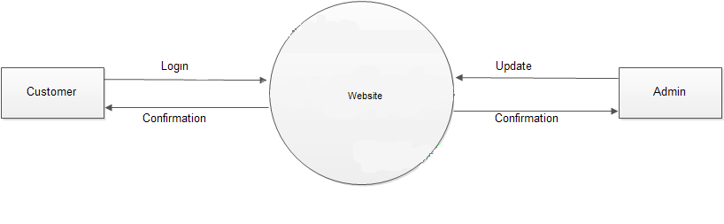

Figure 3.1

## 3.2 User

The User(s) are the main purpose of the site existing and our goal is to meet their need and expectations. Users have the ability to purchase property and to sign into the website.

1. Registration and Login

A new user will have to sign up into the website to be able to access additional features in the website, once the user has signed up they will finally have an account and purchase property. For an existing user they can just log back in into their account and continue what they would usually do.

1. View Property

Property on this site can be viewed by users who have accounts and are successfully logged in.

1. Buy Property

Users who have accounts and are logged in have the ability to actually buy property buy first of all have to begin the purchasing process by paying the down payment which is 5% of the buying price of the property.

1. Save/ Like Property

The system has an add to cart feature. This feature allows users to save property that they are interested in to their own individual user dashboards. Once the property has been saved users can come back to view it at their own time and it will always be there unless the user then decides to remove it.

1. Edit Details

Users are able to change their details as many times as they want and their data will still be secure. The are able to modify their first name, last name, email and even their password. Our system will still remember them because of their user id.

1. Comment

Users are able to comment on any property the wish to comment on. Only users that have been able to login or signup can do so otherwise users that are not logged in can only read the comments posted by other users but they themselves are not able to do so.

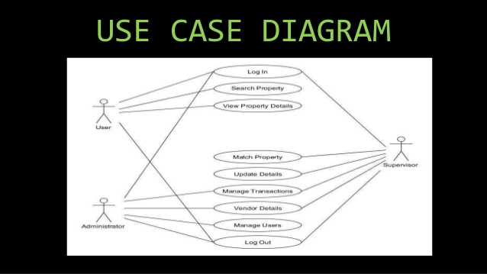

Figure 3.2

# 4 Frontend

## 4.1 Homepage

The homepage is the landing page which most users will see first, the first thing on the homepage are some sliding pages to show users and potential customers what type of property we have to offer. If you scroll down a little bit lower there is a row which displays a few houses and another row slightly lower which then shows some apartments for a quick display.

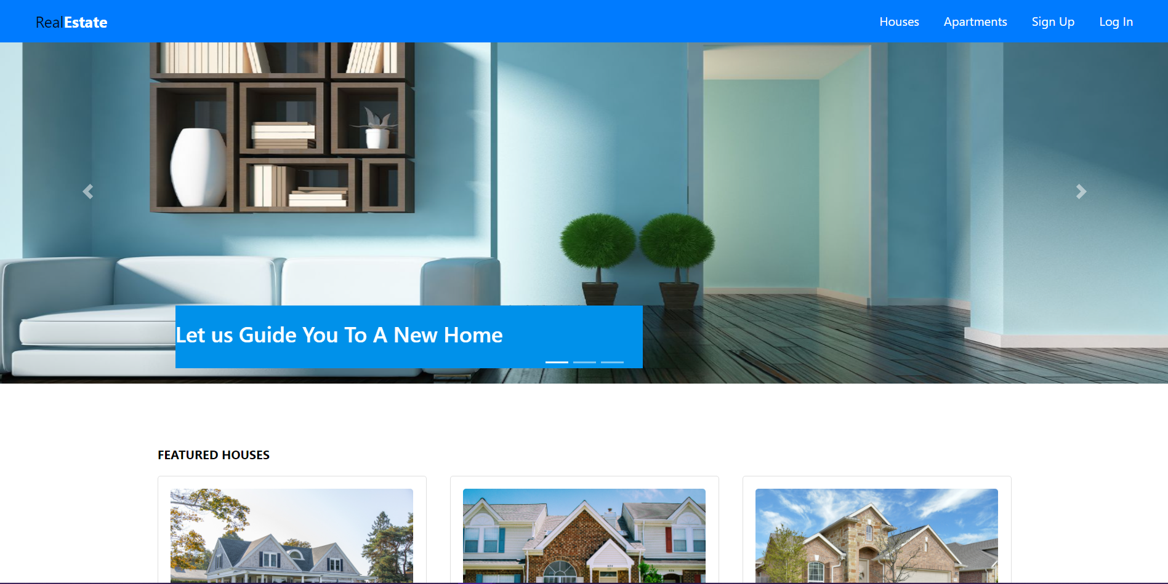

Figure 4.1

## 4.2 Sign-Up Page

On the sign-up page there are 5 fields which are => first name, last name, email, password, and re- enter password.

All these fields details are going to be added to the user database when a user hits the sign-up button, all except the re-enter password. Also, when the password field information is entered to the database the password will be hashed so if an outsider is to ever gain access to the database users’ passwords won’t be leaked. Users passwords are also to remain anonymous to the admin, that is why passwords are hashed.

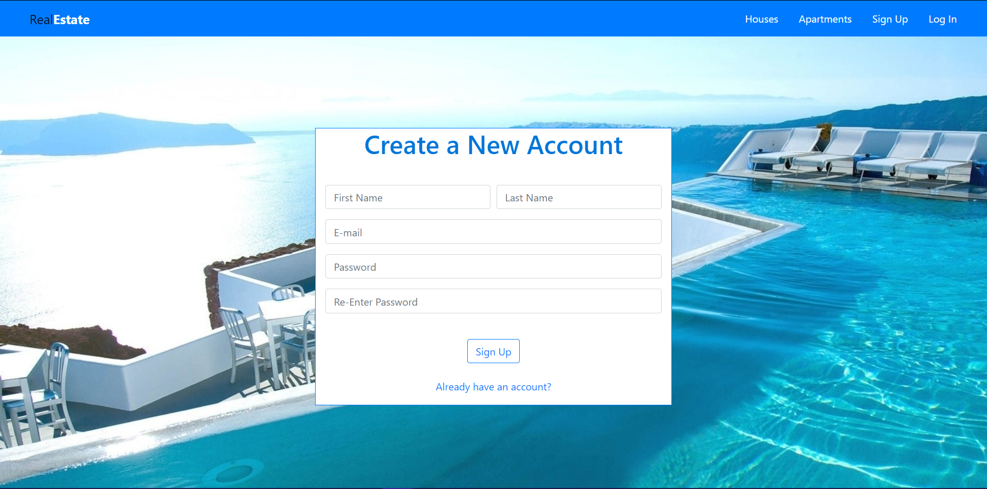

Figure 4.2

## 4.3 Log-In Page

The log in page only has to fields to be filled in and those are the email and the password fields, when the user enters the data it will be sent to a php script which will check the database if there is a row where the exact information of both email and password fields are both true. When that happens, the user will be logged into their account and then sent to the homepage.

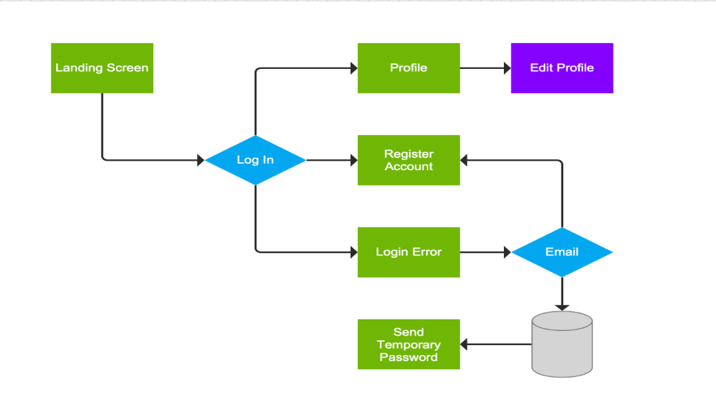

Figure 4.3

## 4.4 User Page

The user page allows the user to log out of their account, it also allows them to deactivate their account and all their data will be removed from the database immediately.

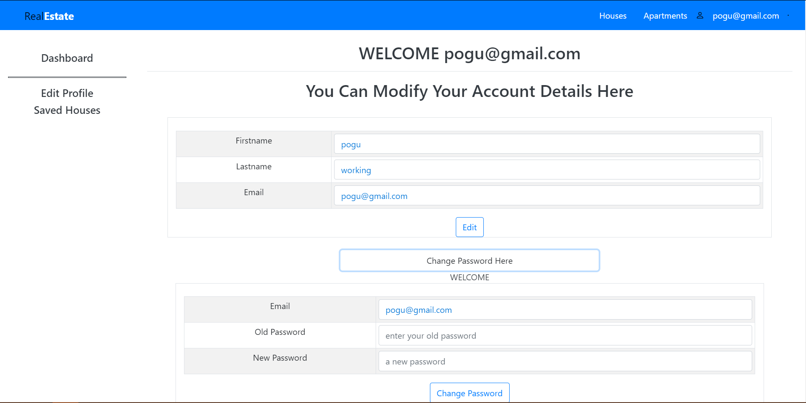

Figure 4.4

## 4.5 House & Apartment Pages

For these respective pages all the houses/apartments are going to be shown. They are separated from each other for easier navigation of what the user may be looking for.

## 4.6 Product Page

On this page all the product pages are formed dynamically, when the user clicks on property the id of the property will be obtained and sent and then used by the product page to then show other rows to display other information about the selected property.

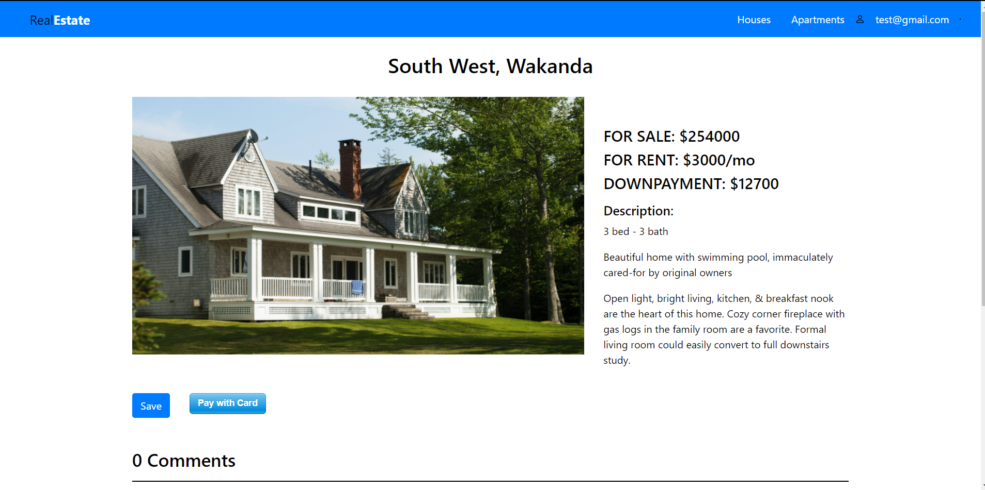

Figure 4.6

## 4.7 Admin Product View

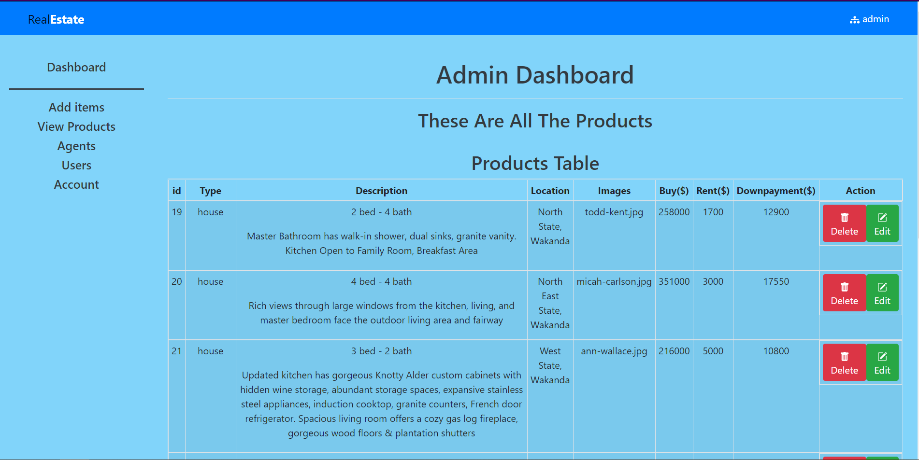

Figure 4.7

# 5 The Backend

## 5.1 Users Table

The users table communicates with the signup and log in pages. This is where all the user’s data will be stored until they then decide to deactivate their account which will then remove their entire field.

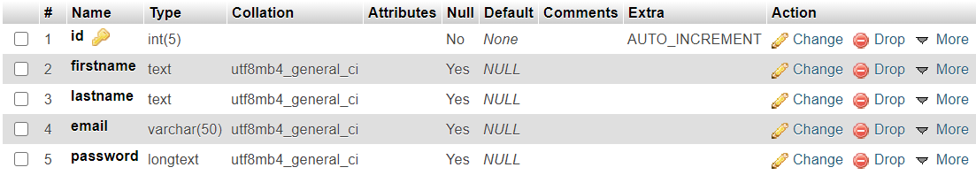

Figure 5.1

## 5.2 Products Table

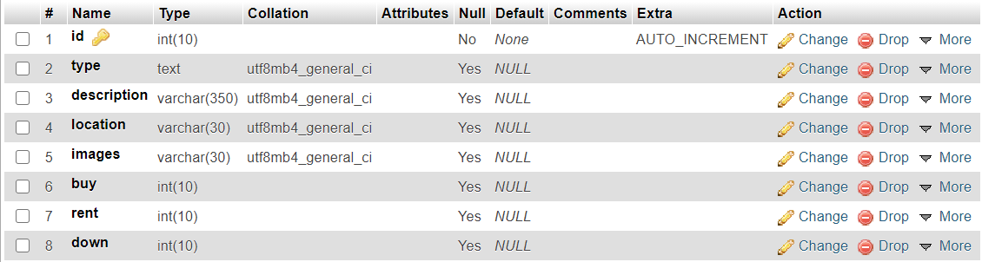

Figure 5.2

## 5.3 Cart Table

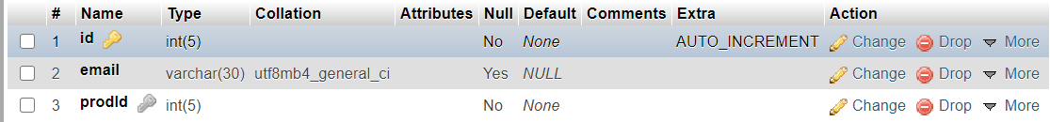

Figure 5.3

## 5.4 Agents Table

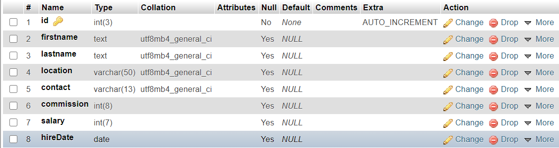

Figure 5.4

# 6 Website Software Testing

Complete testing of a web-based system before going live can help address issues before the system is revealed to the public. Issues may include the security of the web application, the basic functionality of the site, its accessibility to handicapped users and fully able users, its ability to adapt to the multitude of desktops, devices, and operating systems, as well as readiness for expected traffic and number of users and the ability to survive a massive spike in user traffic, both of which are related to load testing.

## 6.1 Functionality testing

Is a process that includes several testing parameters like user interface, APIs, database testing, security testing, client and server testing and basic website functionalities. Functional testing is very convenient and it allows users to perform both manual and automated testing. It is performed to test the functionalities of each feature on the website.

## 6.1.1 Usability testing

The system is tested by inviting a few people to test and determine the site navigation such as the links and buttons. Content is also tested to make sure that there are no spelling errors or an error in the grammar used.

## 6.1.2 Interface testing

The Application, Web and Database Server are tested. For the application it is to make sure that requests are sent correctly to the Database and output at the client side is displayed correctly. The database server is to make sure queries sent to the database give expected results. The web server is where the application requests are handled with no service denial.

## 6.1.3 Database testing

The database is important for the web application, the testing here is to see if any errors are shown while executing queries, data Integrity is maintained while creating, updating or deleting data and for the data retrieved from your database to be shown correctly in the web app.

## 6.1.4 Performance testing

This is to ensure that the site works under all loads. This includes: response times at different connection speeds, web application behavior under normal and peak loads, test if a crash occurs due to peak load and how the site recovers from such an event.

## 6.2 Security Testing

Security Testing is vital for e-commerce website that store sensitive customer information. A way we can test is to test unauthorized access to secure pages should not be permitted, check sessions are automatically killed when a user logs out.

# 7 Methods of Testing

Software testing methods can be divided into different types according to different testing principles. From the perspective of whether the test is aimed at the internal structure of the system and the specific implementation algorithm, it can be divided into white box test and black box test.

If function test is selected, black box test will be selected, which will test different function modules of the program and check whether each function module can operate normally. In the experiment, the test program as a black box hypothesis cannot be opened, and in this process, without considering the internal structure and internal characteristics, test the program interface, check the part, only test whether the functional content of the program can be used normally according to the requirements of the specification, whether the program can receive the input data and generate the correct output information. Black box testing does not consider the internal logic structure, but only focuses on the external structure of the program. It mainly tests the function of the software and the interface function of the software. The test of real estate website mainly uses black box test.

# 8 Conclusion

Websites are playing important part in improvement of business.70% of the population is using dynamic and interactive websites because of their eye capturing visual effects. Static websites also have their own place for the platform where there is specific information required. Static websites require less investment as compare to dynamic websites.

The final result of this paper is to design and implement a real estate website, which is to help potential property owners to find a home. This can also help real estate enterprises in the future to operate more as daily activities and leisure seem to be integrated online. Finally, it proves the application value of Internet technology and the great development potential of internet real estate.

In the long process of designing and developing this website, I now have a better understanding of websites. User experience and design of the website is extremely important. A well-designed website can leave a deep impression on the user and improve the user's interest for browsing or visiting the site again. The convenience and simplicity of website operation is also very important. The website interface should allow users to quickly access key information and interact effectively. According to the demand analysis of real estate website, a large number of pictures are needed.

Through the development of this website, I now have a better understanding of the design and development specifications of software engineering specifically websites. I understand that before system development, a perfect design scheme is very important for system development. When facing technical problems, I learn how to solve them. By searching information to expand my knowledge, I will accumulate experience and technology for future system development.

# 8 References

[1] <https://en.wikipedia.org/wiki/Web_testing> (Page 21)

[2] <https://www.guru99.com/web-application-testing.html#:~:text=What%20is%20Web%20Testing%3F,the%20web%20application%20or%20website>. (Page 21-22)

[3] <https://www.guru99.com/complete-web-application-testing-checklist.html> (Page 21-22)

[4] <http://studyyypointtt.blogspot.com/2013/11/data-flow-diagrams-for-online-shopping.html>

[5] <https://themortgagereports.com/18520/20-percent-downpayment-risk-mortgage-interest-rate#:~:text=How%20much%20down%20payment%20you,%248%2C750%20on%20the%20same%20house>.

[6] <https://www.thebalance.com/real-estate-what-it-is-and-how-it-works-3305882#:~:text=Real%20estate%20also%20refers%20to,critical%20driver%20of%20economic%20growth.&text=Real%20estate%20agents%20assist%20homeowners,all%20four%20types%20of%20properties> (Page 7)

[7] <https://www.mysqltutorial.org/mysql-foreign-key/#:~:text=First%2C%20specify%20the%20name%20of,after%20the%20FOREIGN%20KEY%20keywords>.

[8] <https://sweetalert2.github.io/> (Page 9)

[9] <https://www.php.net/manual/en/intro-whatis.php> (Page 9)

[10] <https://unsplash.com/photos/biepNX5n7r4>

[11] <https://www.w3schools.com/jsref/met_win_alert.asp>

[12] <https://getbootstrap.com/docs/4.2/layout/overview/> (Page 9)

[13] <https://teamtreehouse.com/community/help-me-understand-how-we-use-get-to-create-a-product-detail-page> (Page 18)

[14] <https://medium.com/@mauricemuteti2015/how-to-upload-and-insert-image-into-mysql-database-using-php-and-html-32633a06d372>

[15] https://stackoverflow.com/questions/17717506/how-to-upload-images-into-mysql-database-using-php-code